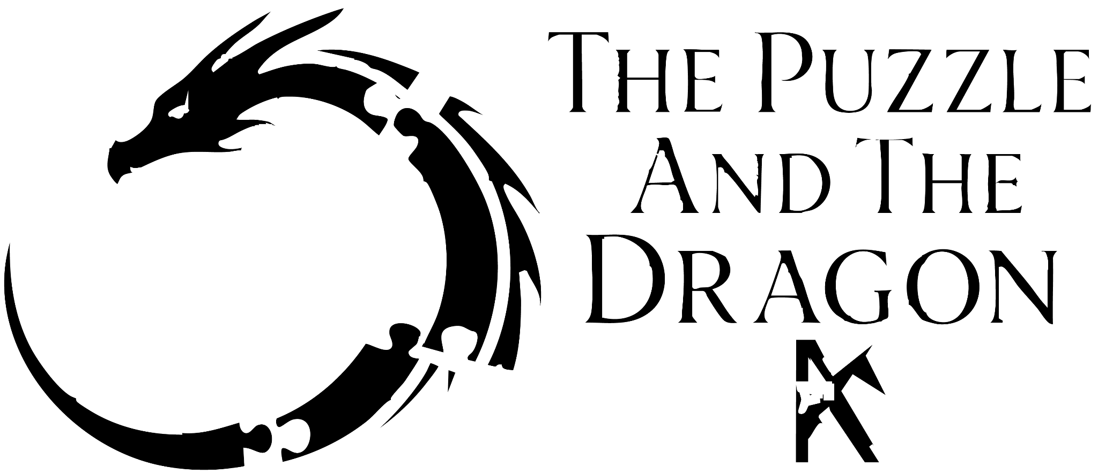

By Kyle Young

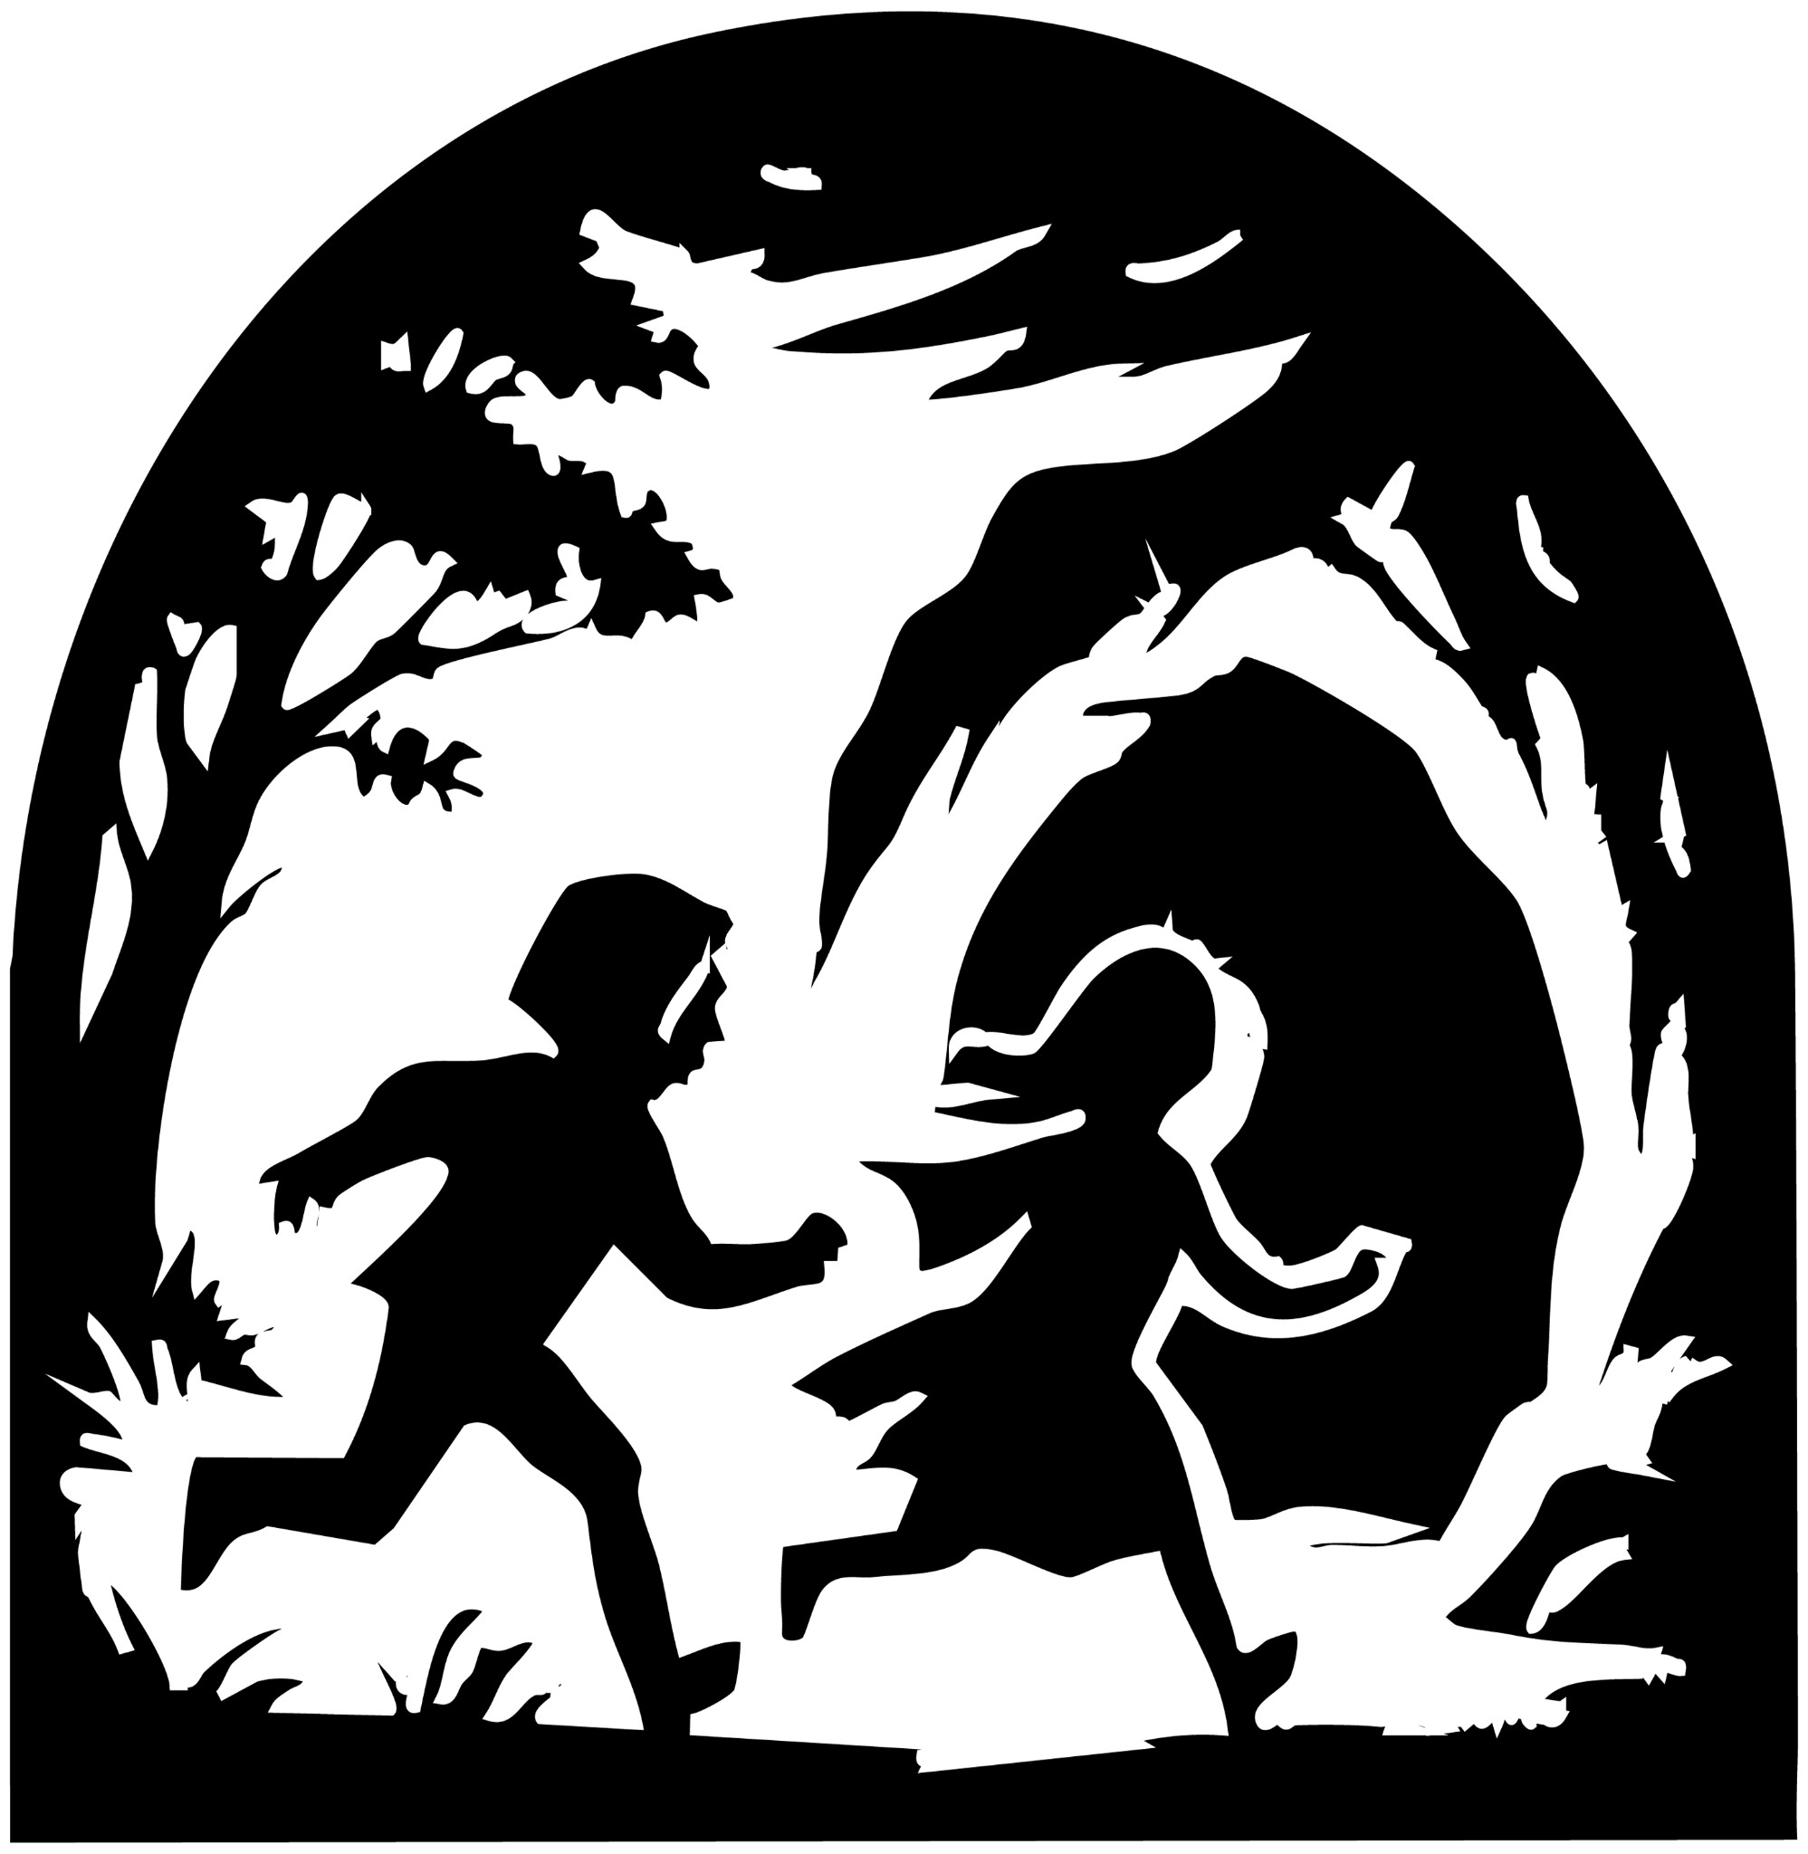

The Allure of a Mystery
Once upon a time, deep within a forest where magical trees sang softly in the wind, there lay a mysterious puzzle. It was no ordinary puzzle, for each piece was enchanted, shifting shapes if ever placed incorrectly. Legend whispered that once completed, it would grant a single wish, powerful enough to alter destiny itself.

On a blustery evening, beneath clouds that danced like silver threads across the darkening sky, two friends—a boy wearing a hood green as fresh grass, and a girl in a cloak as blue as the endless sky—hurried homeward. But fate, guided by mischievous winds, turned their path astray, leading them to a cave beside the puzzle.

Seeking shelter from the storm, the boy gently wrapped his arms around the girl to shield her from the biting cold. As lightning flickered softly, his curious eyes drifted toward the puzzle pieces, glinting in the moonlight. When the tempest calmed, the boy approached the puzzle, lifting a piece that felt lighter than air itself.

“Come,” urged the girl, her voice gentle yet firm. “Our parents will worry.”

Reluctantly, the boy released the block onto the wooden canvas. As it touched down, it transformed into a perfect sphere, causing every other piece to shift shapes as if alive. Startled, he stepped back, but the girl grasped his hand, pulling him onto the path back home.

Yet the puzzle had cast a spell upon the boy’s heart, one that drew him back each day. Years rolled by like tides upon a shore, and every day he returned, tirelessly arranging the enchanted pieces.

One day, grown older yet still hopeful, he brought the girl, now a maiden, to witness his work. She gazed at the puzzle, fear flashing briefly across her eyes. Without a word, she pushed him gently away, fleeing the place, leaving him alone with a heavy choice: to follow her or to remain. He chose the puzzle, bound by a mystery he believed worth unraveling.

The years slipped by like falling leaves. The boy became a man, then an elder. He saw the magical trees bloom and wither, still chasing the elusive dream the puzzle promised. One day, the woman returned, now aged like him, and for a brief, joyful moment, he abandoned his task to share warmth and laughter. But she left again, leaving only silence behind.

Determined, he continued. Yet one stormy evening, the wind whispered a new clue as a puzzle piece tumbled atop another. With eyes wide in astonishment, the elder cried out, “Perhaps it is three-dimensional!”

With newfound hope, he placed the pieces upward, forming a statue—a figure of himself as a boy pointing curiously toward the cave. In wonder, he gazed within the darkness, only to feel sudden despair.

“All these years, was it for nothing?” he asked the shadows.

At that moment, a brilliant beam pierced the clouds, illuminating the statue and revealing a creature of legend—a shimmering blue dragon emerging from the cave.

“You have solved my puzzle,” spoke the dragon gently. “I shall grant you a single wish.”

The old man gazed at his weathered hands and whispered sorrowfully, “I wasted my life chasing a dream I never truly desired. Send me back—to the first moment I laid eyes upon your puzzle.”

Bowing graciously, the dragon circled him, and in an instant, time unraveled.

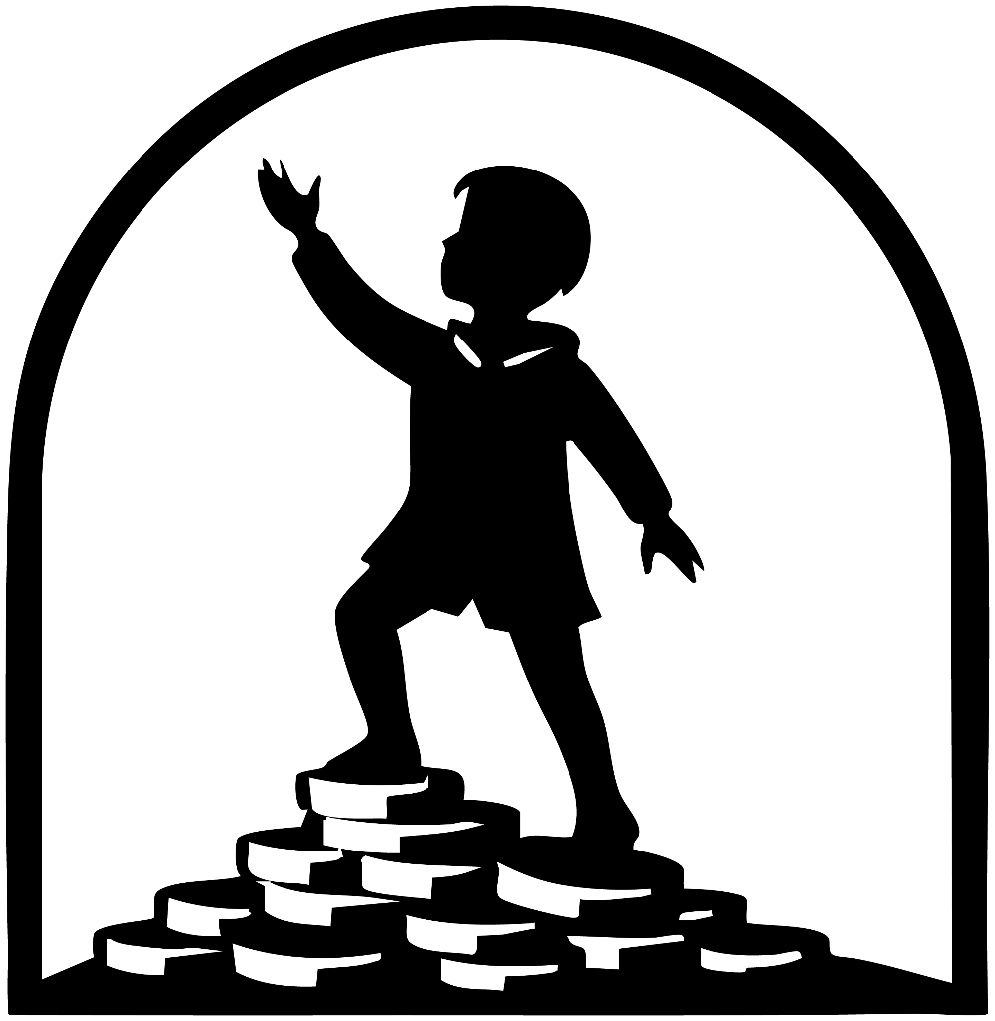

The Gift Of Time
He stood again as a boy in a green hood, arms around the girl as the storm ceased. She smiled, gently urging, “Let’s go home; they're waiting for us.”

He smiled softly, whispering, “I won’t waste this life,” as he followed her away.

But time flows strangely around enchanted puzzles, and destiny drew him back once more as an old man. This time, when the dragon appeared again, he sighed deeply.

“I've spent this life carefree, chasing whims, yet I have nothing of meaning to show for it. Let me return again.”

The dragon honored the wish, spinning time backward. Again he relived his days, this time dedicating himself to great deeds—building homes, giving shelter to countless souls. Yet again, at life's twilight, loneliness gnawed at his heart. Summoning the dragon once more, he whispered his deepest truth.

“I gave all to others yet forgot love. Return me again, and this time I shall find the one my heart longs for.”

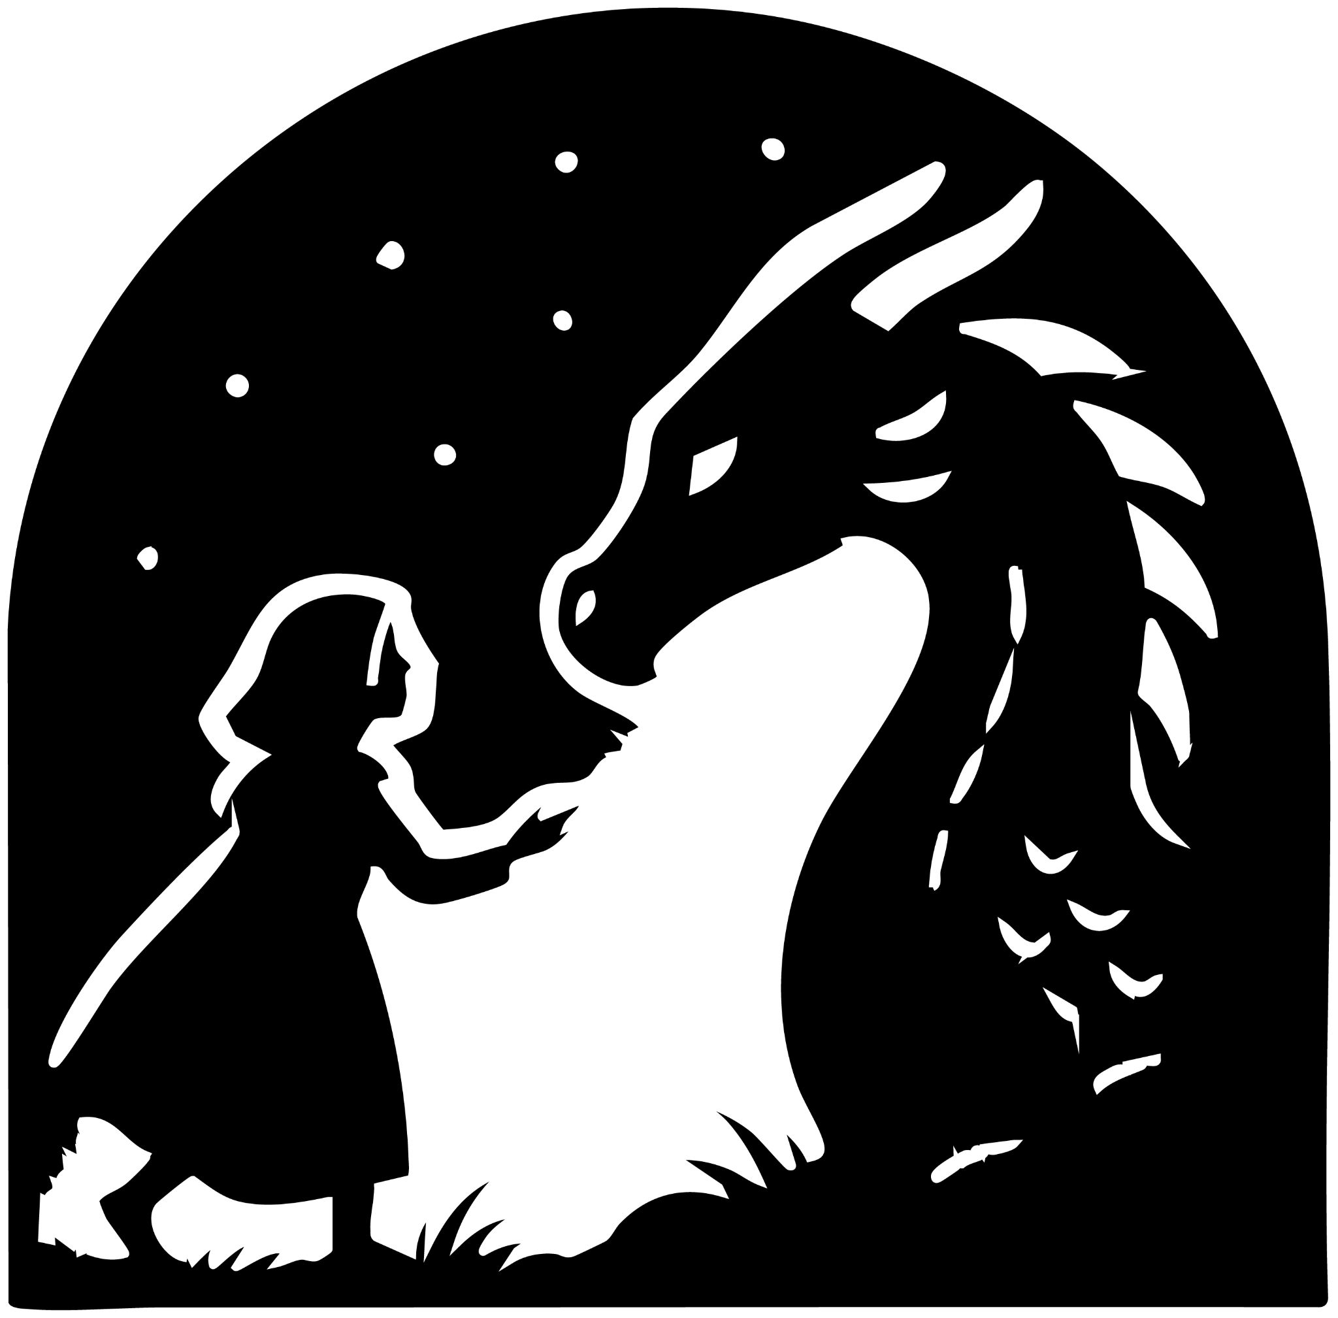

The Gift Of Love
The wish granted, he returned once more, this time weaving his path together with the girl in the blue hood. They lived lovingly, aging gracefully side-by-side until, at last, together they approached the puzzle as elders. The dragon appeared, patient as eternity itself.

“You have solved my puzzle,” it spoke softly. “One wish is yours.”

Hand in hand, the man spoke warmly, “We have lived beautifully, yet this life seems too fleeting. Grant us youth again, and the gift of endless days together.”

The dragon circled gently, restoring them to youthful splendor, and watched quietly as they vanished into a new story together. Believing his duty complete, the dragon rested peacefully, while centuries passed like breaths. Yet time brought change, forests rose and fell, and one day the woman in the blue hood returned, alone, determined to recreate the puzzle. It resisted her for years, yet finally formed a statue—a vision of herself pointing toward the cave.

“You have solved my puzzle,” the dragon spoke again, curious. “Tell me your wish.”

With silvery tears in her eyes, the maiden spoke in a voice trembling like the first breath of dawn:

“I have watched lifetimes unfurl before me—seen hearts shatter and mend, witnessed kingdoms awaken and crumble to dust. Yet time and again, my love has lost himself within the shifting years, never to return as the boy whose hand first found mine. I have learned that life is woven from choices and their echoing consequences, and that no path we wander can undo the steps we have taken.”

She paused, letting sorrow wash over her like a rising tide. “But, my dearest, I can no longer bear the shadow he has become. He is naught but a ghost of the youth we once were, when we stood here together, yearning for endless days before your enchanted puzzle. I did not know then how much pain we would carry, nor how deeply those bright days would change us. We became prisoners of our own desire, trading our souls for immortal breath.”

Her voice caught as fresh tears fell. “So grant me this wishes, O keeper of fates: I wish for this pain would end and the gift of your power would be taken from this world, so you may rest in peace.”

Touched, the dragon bowed deeply. Circling her one last time, it honored her wish. In a flash, the puzzle dissolved forever. Opening her eyes, she saw the boy in the green hood holding her close, warm against the chill breeze.

In that tender embrace, hope bloomed eternal, and the dragon rested at last, content beneath the sky that sang softly of evermore.

